UNIVERSITY OF ENERGY AND NATURAL RESOURCES

SUNYANI



**HEART DISEASE PREDICTION USING HYBRID 1D CONVOLUTIONAL NEURAL NETWORK AND BIDIRECTIONAL LONG SHORT-TERM MEMORY**

BY

NSOH PETER UEB3205220

TAMAKLOE HOPELAND UEB3215420

BATSA RUTH MAMILE UEB3201020

TANNOR JUSTICE BOAFO UEB3212320

AMANKONA YEBOAH MAXWELL UEB3213420

A PROJECT WORK SUBMITTED TO THE DEPARTMENT OF INFORMATION TECHNOLOGY AND DECISION SCIENCES. UNIVERSITY OF ENERGY AND NATURAL RESOURCES IN PARTIAL FULFILMENT OF THE REQUIREMENTS OF THE BACHELOR OF SCIENCE IN INFORMATION TECHNOLOGY SCHOOL OF SCIENCES

SEPTEMBER, 2024

# **DECLARATION**

I, Nsoh Peter, Batsa Ruth Mamile, Tamakloe Hopland and Tannor Justice Boafo declare that the submission of this work is own for the award of a BSc. Information Technology. All rights are observed to extract from or entirely omit part of the work for publication. This work does not include content published by other people except due credit is given where appropriate in the text.

NSOH PETER ...……………... ..….…………

**(UEB3205220**) DATE SIGNATURE

BATSA RUTH MAMILE ………........... ..…………..….

(**UEB3201020**) DATE SIGNATURE

TAMAKLOE HOPELAND ……………... ……….……...

**(UEB3215420**) DATE SIGNATURE

TANNOR JUSTICE BOAFO …………….... ……….……...

**(UEB3212320**) DATE SIGNATURE

AMANKONA MAXWELL ……………… ..………….…..

(**UEB3213420**) DATE SIGNATURE

DR. KWABENA ADU …………… ……….…..

(**SUPERVISOR**) DATE SIGNATURE

PROF. PETER APPIAHENE …….…….…… ….…………..

(**HEAD OF DEPARTMENT**) DATE SIGNATURE

# **DEDICATION**

We dedicate this work humbly to the department of this prestigious institution whose constant training and guidance has equipped us with the necessary knowledge and skills to be able to complete this work. To our parents, family, and guardians, whose untiring support and assistance have made the fruition of our efforts to produce this work possible. To our lecturers and supervisors who impacted us with the necessary knowledge and skills needed to complete this work.

# ACKNOWLEDGEMENT

We give glory to Almighty God for guiding us to complete this work. We will always be grateful to our industrious supervisor Dr. Kwabena Adu for his unfailing guidance throughout the period in the form of mentorship and direction. We would also like to take this opportunity to thank his teaching assistants for their support throughout the project session till the end. We would not forget to appreciate ourselves for our dedication, discipline and commitment from the beginning of the project to this end.

Finally, for our loved parents whose constant prayers and good wishes provided encouragement throughout the period, we are so grateful.

# **ABSTRACT**

Heart is one the vital organ for human survival. Unfortunately, heart disease is one of the primary causes of mortality worldwide and its occurrence keeps increasing. Targeted early detection methods for cardiovascular diseases are also instrumental in identifying high-risk candidates and then intervening accordingly to decrease their risk. This study seeks to identify a heart condition where in its early stage in order to save lives. This project introduces the study of the architectural design for a hybrid model deploying Deep learning techniques, 1D Convolutional Neural Networks (1D CNN) and Bidirectional Long Short-Term Memory (Bi-LSTM) for predicting heart disease and generate critical diagnostic strategies

This is achieved by using Heart Disease Cleveland UCI data from Kaggle and StandardScaler is applied to the dataset to scale all features and put them on a same scale and this helps the model *converge more quickly* during training. The proposed model’s performance and efficiency is demonstrated by the results obtain from the experiments on the dataset obtained from Kaggle. Performance Metrics such as accuracy, precision and f1-score are used to evaluate of the performance of the model. When tested on 1,191 data samples the model achieved an accuracy of 93.70% against traditional machine learning which achieved with the best technique 86.5%.

**TABLE OF CONTENT**

DECLARATION i

DEDICATION ii

ACKNOWLEDGEMENT iii

ABSTRACT iv

BACKGROUND 1

1.0 Introduction 1

1.1 Problem Statement 2

1.2 Significance of the Study 3

1.3 Main Objective and Specific Objectives 3

1.4 Specific Objectives: 3

Literature Review 4

2.0 Introduction 4

2.1 Definition of Concepts 4

2.1.0 Machine learning 4

2.1.1 Deep learning 4

2.1.2 1D Convolution Neural Network (1D CNN) 5

2.1.3 Bidirectional Long Short-Term Memory (Bi-LSTM) 5

2.2 Review of Related Works/Systems 5

Methodology 9

3.0 Introduction 9

3.1 Data Description 10

3.2 Data preprocessing and splitting 12

3.2.0 Normalization of Features 12

3.2.1 Data splitting 12

3.3 Model Design 13

3.3.0 Model Architecture 13

3.3.1 One Dimension Convolutional Neural Network (1D CNN) 13

3.3.2 Bidirectional Long Short-Term Memory (Bi-LSTM) 14

3.3.4 Model Layers 14

3.3.5 Model summary 14

3.3.6 Model Training and Evaluation 15

3.4 Deployment 17

Results and Discussions 18

4.0 Introduction 18

4.1 Experimental setup 18

4.2 Performance Metrics 19

4.3 Experimental Results 20

4.4 Plot of the training history 20

4.5 Confusion Matrix of the proposed model 21

4.6 Comparative Results Table and Plot 22

CONCLUSION 24

Appendix 29

Codes for the model building 29

Interface of the web app 33

**FIGURES**

Figure 3.1: Flow chat of the propose methodology. 10

Figure 3.2: Dataset attribute description. 11

Figure 3.3: Nominal attribute description. 11

Figure 3.4: Model Architecture. 13

Figure 3.5: Model summary. 15

Figure 4.1: Model history plot. 20

Figure 4.2: Confusion matrix of the model. 21

figure 4.2: Comparison table . 23

Figure 4.3 Plot of the comparative results 23

**CHAPTER ONE**

# **BACKGROUND**

## **Introduction**

According to the World Health Organization, by 2030 there would be an escalation of 24.5 million death rate from health risk factors such hypertension, blood pressure and kidney failure including smoking. (WHO, 2020). For example, in many cases it is extremely important that if a patient wants to save his life, he should go to the doctor as soon as possible and such patients can be saved from going down to death to keep doctors always aware of their health situation. (Shrivastava et al., 2023)

The heart is an essential organ in human body. As a result, forecasting and comprehensive evaluation of CVD is also of great importance. The main reason why patients die from these illnesses such as heart disease is that they are typically predicted too late. For this reason, it necessitates the development of reliable algorithms for their early prediction.

Research efforts have gone into the direction of improving the capability of detecting heart related complications at the earliest stages as well as reducing mortality cases. Several research publications have successfully applied different kinds of machine learning and deep learning algorithms to diagnose and predict heart disease. A backpropagation neural network (BPNN) with six hidden layers and data sharing in the ratio of 60:40 is employed to forecast heart disease. That means 85% accuracy is achieved; It has been shown that BPNN is better and consistent in diagnosing heart disease (Helwan et al, 2021. A deep learning model designed combining 1D CNN and Bi-LSTM to predict heart disease which utilized 165 samples and results achieved an accuracy of 96.66% making it a robust and efficient model (Shrivastava et al., 2023). However, it is found out that all these studies among others are using relatively low dataset samples which still gives room for further studies to be conducted on this topic using large dataset sample.

The scope of this project is to develop and implement a hybrid 1D Convolutional Neural Network and Bidirectional Long Short-Term Memory for heart disease prediction. The 1D CNN part is responsible for extract the spatial attributes from the information, while temporal patterns and sequence information is well captured by the Bi-LSTM part. We therefore would like to amalgamate these two models as one model in order to build a strong and reliable system for prediction.

## **1.1 Problem Statement**

As in other populations, heart-related illnesses are a major health burden and are among the highest causes of mortality and illness. The approach in this context depends primarily on extensive real time assessment of recorded medical information, hence, the use of combination methods may result in a delay or erroneous diagnosis. Moreover, due to the heterogeneity and multifaceted nature of the symptoms of the heart conditions, coming up with a standard disposal diagnostic tool is an uphill task. The objective of this project is to solve this problem by utilizing the full potential of two deep learning algorithm that is; 1D Convolutional Neural Network and Bidirectional Long Short-Term Memory to provide early diagnosis and make accurate heart disease predictions using Heart Disease Cleveland UCI dataset. The proposed model aims at improving diagnostic accuracy with a high-level operational reliability of an early intervention tool in order to improve patient care.

## **1.2 Significance of the Study**

This study seeks to improve the early detection of heart diseases through the use of a hybrid deep learning model which incorporates 1D CNNs with Bi-LSTMS. This model bears little risk of data constraints and predicts with great accuracy, thus helping clinicians to make correct and timely decisions which can prevent loss of lives and reduce costs of healthcare. The use of advanced machine learning and deep learning algorithms in the clinical setting is a revolutionary advancement in the field of diagnosis and management of patients.

## **1.3 Main Objective and Specific Objectives**

The main objective of this project is to develop and implement hybrid Bidirectional Long Short-Term Memory and 1D Convolutional Neural Network to predict heart disease

## **1.4 Specific Objectives:**

* To design and implement hybrid Bidirectional Long Short-Term Memory and 1D Convolutional Neural Network to predict heart disease.
* To train and optimize deep learning models using the collected dataset, incorporating techniques such as hyperparameter tuning and cross-validation.
* To evaluate the performance of the developed models using performance metrics such as accuracy, precision, recall and f1 score
* To compare the performance of the different machine learning models and assess their feasibility for real-world deployment in clinical settings
* Deploy the model on web

**CHAPTER TWO**

# **Literature Review**

## **2.0 Introduction**

In this section, we explore deep about what previous research have made about the study. It covers the previous opinions about the concepts used in this study and the related works or systems made that contribute significantly to heart disease prediction.

## **2.1 Definition of Concepts**

### **2.1.0 Machine learning**

Machine leaning is the branch of Artificial Intelligence in which computers are designed to mimic human thinking capacity and reasoning using computational algorithms. Machine learning utilizes different techniques such as data analysis, data mining which can be applied in computer vision, financial and accounting, entertainment, patter recognition and computational biology (Naqa and Murphy 2015).

### **2.1.1 Deep learning**

Deep learning is a type of machine learning that are based on neural networks that uses multiple layers to to process and extract features with each concept defined in relation to simpler concepts, and more complex representations computed in terms of less abstract ones (Bengio, Y et al, 2017).

### **2.1.2 1D Convolution Neural Network (1D CNN)**

This is a king of deep learning that is specially made to handle sequential data, such time series or signals. 1D CNNs work on one-dimensional data, employing filters to extract local features, unlike conventional 2D CNNs used for image processing. These filters follow the sequence and pick up patterns such as repetitions, peaks, and trends. The main advantage of 1D CNNs is that they can learn to filter out relevant features in an exogenous data stream. features from the raw input data, and thus they can be applied in tasks such as text mining, medical, etc.   
diagnostics, and signal processing (El-Shafiey et al., 2021)

### **2.1.3 Bidirectional Long Short-Term Memory (Bi-LSTM)**

Bidirectional LSTMs is a subclass of Recurrent Neural Network, which integrate both forward and backward information. It also manages to capture the relationship between the front information and the back information in an effective manner (Yang, J et al, 2020).

## **2.2 Review of Related Works/Systems**

Hybrid deep learning algorithm combining the power of bidirectional LSTM and 1D CNN model implemented with an optimization call Bayesian to predict heart disease. Their study utilized dataset from California University’s Cleveland and Statlog dataset. Using 303 and 270 samples from the two datasets respectively, the proposed method achieved an accuracy of 89% and 83% on the Cleveland and Statlog dataset respectively making it the best performed approach in that study respectively (El-Shafiey et al, 2021). Research conducted to proposed an algorithm or system for heart disease prediction. The study employed a deep learning algorithm that combines the power of Convolutional Neural Network (CNN) and Bidirectional Long Short-Term Memory (Bi-LSTM). The proposed approach is then compared with other traditional machine learning algorithms using the various performance matrices. At the end of the assessment, the proposed method achieved highest accuracy of 96.66% much way more than the other algorithms (Shrivastava et al., 2023). Heuristic-based channel selection with enhanced deep learning for heart disease prediction via Wireless Body Access Networks (WBAN) was designed to accurately predict heart disease. Their study involves three stages namely, data segregation stage, channel selection stage and heart disease prediction stage. At the end the study, the proposed methodology achieved comparatively high accuracy result than those it has been compared with (Muthu Ganesh & Nithiyanantham, 2022)

Hybrid approach that combines Random Forest with Bi-directional Long Short-Term Memory (BiLSTM) was implemented to enhance the accuracy of heart disease prediction. The study shown that this hybrid model leverages the strengths of both algorithms: Random Forest's ability to handle large datasets with higher accuracy and BiLSTM's capability to capture temporal dependencies in sequential data. The hybrid approach was rigorously tested against other existing algorithms, and the results proved a significant improvement in prediction accuracy. Specifically, the Random Forest with BiLSTM model achieved a notable accuracy of 90%, surpassing other methods in the study (Kumari 2021). Machine learning based system for heart disease prediction was designed to accurately and precisely predict patient with heart disease. In their study, they use employed deep learning algorithm using keras with 3 layers neurons. The proposed system is then compared with the other traditional algorithms using performance matrices. The results show that, the proposed approach achieved an accuracy of 83%, sensitivity of 90% and f1-score of 89%, outperforming the conventional machine learning models (Almazroi et al., 2023) .

Advanced system combining the power of deep learning algorithm with IoT technology was designed to predict heart disease using algorithm such as Bi-LSTM model to capture patterns in patient data. To assess the performance of the proposed method, the performance of the proposed method is compared with other conventional algorithms and has proven to be the best with accuracy of 98.8% (Alzakari et al., 2024). A machine learning technique for predicting heart disease using the Cleveland heart disease dataset. The study makes use of data mining techniques, specifically classification and regression, and applied decision tree and random forest algorithms. The research introduced a novel hybrid model combining both decision tree and random forest approaches. The experimental results confirmed the hybrid model achieved an accuracy of 88.7% in predicting heart disease. The model was designed to take user input parameters and use the hybrid approach for heart disease prediction (M. Kavitha et al., 2021). A deep learning-based system called Optimally configured and Improved Deep Belief Network was implemented to predict heart disease. The study focused on all the various factors that can potentially affect the performance of heart disease prediction system; that’s solving overfitting and underfitting problem, solving network configuration issues and optimization problem. They utilized Ruzzo-Tampo to eliminate all the features that do not contribute to the general performance of the system and also improving the network configuration using stacked genetic algorithm. At the end of the study, the proposed approach has proving to be the best with high accuracy of 94.61% can provide a reliable recommendation for heart disease patients (Ali et al., 2020)

A study was conducted on heart disease prediction using machine learning and deep learning. Several experiments were carried out on both the deep learning and machine learning to compare their performance outcome and at the end of the study, the results achieved by deep learning proved to be higher of machine learning by showing consistency in a satisfactory range between 84% to 99% (Bakar W. A, et al, 2013). Enhanced machine learning approach designed using Ensemble classifier with Support Vector Machine (SVM) for heart disease prediction. The main objective was to develop a robust machine learning algorithm hat has high accuracy of predicting whether person has heart disease or not. To achieved this the study utilized Cleveland dataset from Kaggle and then applying Ensemble classifier for process features. At the end the study, the approach is compared with other traditional algorithms to assess its performance using performance matrices. The proposed approach achieves high performance with accuracy of 91%, f1-score of 91% and 96% sensitivity making it the best algorithm among the other algorithms (Sharma & Singh, 2022)

Research conducted to develop a heart disease prediction algorithm using machine and Linear based model approach. In the study, they proposed a novel methodology that combines the power of Random Forest with linear model (HRFLM) which aims to streamline and find a significant feature using machine learning and deep learning algorithms to improve the accuracy in predicting heart disease. The proposed approach resulted in achieving high accuracy of 88% and enhanced performances of predictions (Mohan, S., et al, 2019). A robust heart disease prediction system developed using hybrid Deep Neural Network (HDNN). The goal is to combine the capability of Artificial Neural Networks (ANN), Convolutional Neural Networks (CNN) and Long Short-Term Memory (LSTM) design a robust model. Using the performance matrices to assess the model accuracy and efficiency, the proposed approach achieved very high accuracy of 98.86% confirming it as the best approach for heart disease prediction (Reshan et al., 2023)

**CHAPTER THREE**

# **Methodology**

## **3.0 Introduction**

This section provides a method and the process that has been followed for this study. The methodology utilizes an integration of 1D Convolutional Neural Networks (1D CNN) & Bi-directional Long Short-Term Memory (BLSTM) to predict heart disease. The following steps used in the methodology procedures that are involved in data collection, data processing, constructing performance model and performance. evaluation metrics which include accuracy, precision, recall and f1 score. Figure 3.1 certainly depicts the flow of activities to be done as in the methodology

**Flow chart of the propose methodology**

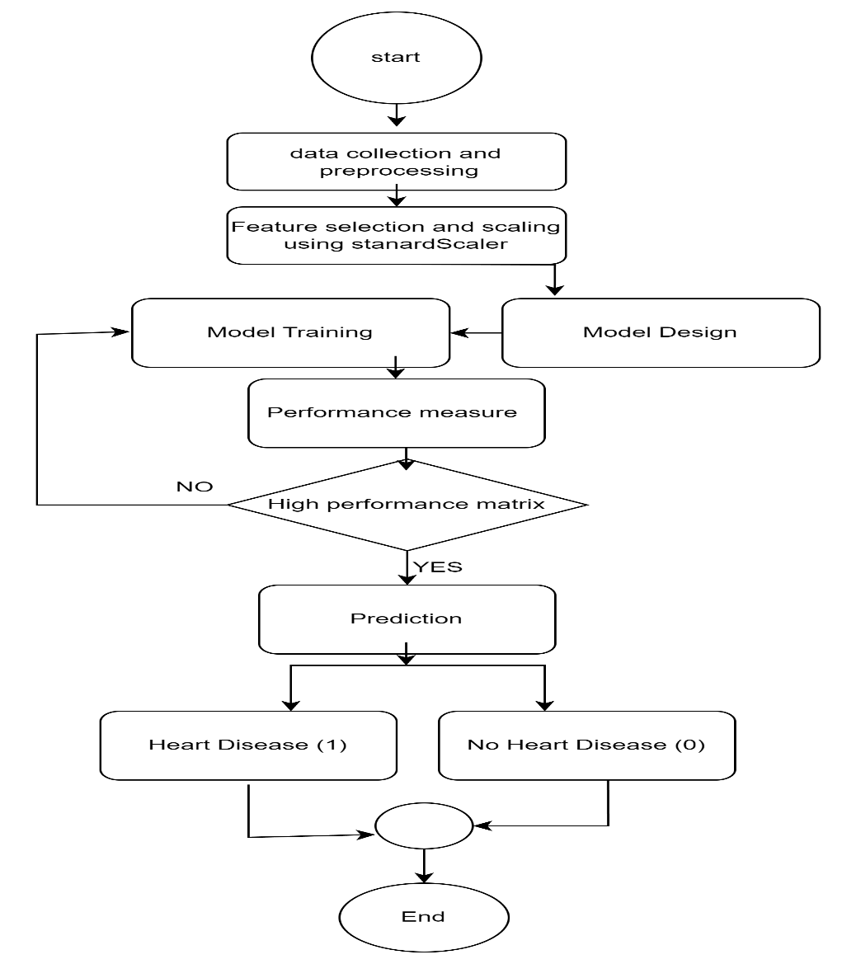

#### **Figure 3.1: Flow chat of the propose methodology.**

The Figure 3.1 above represents the flow of activities involve in the proposed method. To achieve a successful model, there are series of steps or procedures involve right from data collection to the final prediction

## **3.1 Data Description**

The dataset used was collected from Kaggle and comprises of 1190 records with **13 features**. The dataset is intended for predicting heart disease and includes both categorical and numerical features. The target variable, **disease**, indicates the existing (1) or absence (0) of heart disease. The tables below show a details description of the dataset.

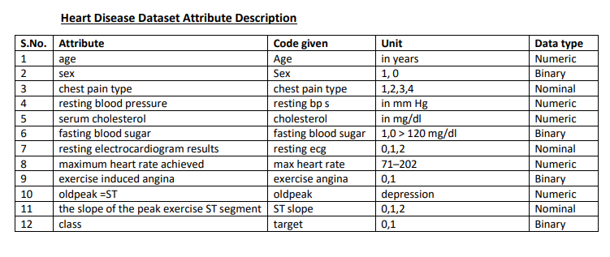

#### **Figure 3.2: Dataset attribute description.**

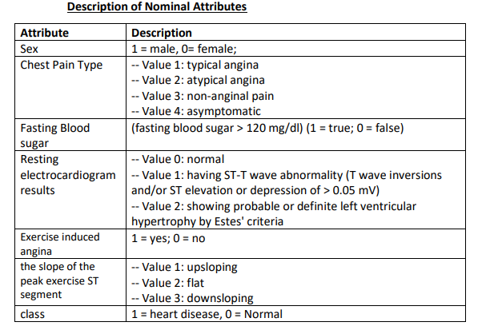

#### **Figure 3.3: Nominal attribute description.**

Figure 3.2 gives the attribute description of the dataset whiles Figure 3.3 describes the nominal attribute of data which was used in training the model.

## **3.2 Data preprocessing and splitting**

Data preprocessing is a relevant step in preparing and loading the dataset for training the model. During this process, the raw data is transformed into a format that is suitable for deep learning algorithm.

### **3.2.0 Normalization of Features**

 Normalization transforms features to be on a similar scale. This helps the model *to come together more quickly* during training. When different features have different ranges, the gradient descent can "bounce" and slow convergence. In this study, StandardScaler is utilized ensures that all the features are centered around the mean and the variance. This is important since some very useful features might have a naturally high scale. For example, age.

### **3.2.1 Data splitting**

The dataset was split into training and test sets with 80/20.

* 1. **Training Set (80%):** Part of the dataset used in training the model, where the model learns to identify relationships and patterns in the data.
  2. **Test Set (20%):** The test set is held back from the training process and used to access the model's performances.

## **3.3 Model Design**

In this phase, the designed is built and train using the combined strength of 1D Convolutional Neural Networks and Bidirectional Long Short-Term Memory networks

### **3.3.0 Model Architecture**

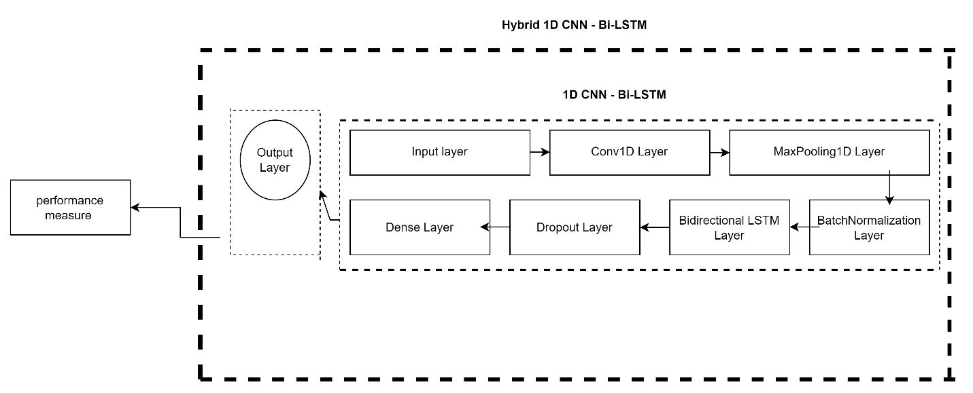

#### **Figure 3.4: Model’s Architecture**.

Figure3.4 shows the model’s architecture. It shows the various components or layers and how they are connected to each other to form a full hybrid 1D CNN and Bi-LSTM model. Below is the explanation of the various layers.

### **3.3.1 1D Convolutional Neural Network (1D CNN)**

This is the type of deep learning approach that is especially made to handle sequential data, such time series or signals. 1D CNNs work on one-dimensional data, employing filters to extract local features, unlike conventional 2D CNNs used for image processing. These filters follow the sequence and pick up patterns such as repetitions, peaks, and trends. The main benefit of 1D CNNs is that they can automatically identify and give meaningful characteristics from the unprocessed input data, which makes them useful for tasks like text analysis, medical diagnostics, and signal processing (Y. LeCun et al,1989).

### **3.3.2 Bidirectional Long Short-Term Memory (Bi-LSTM)**

Bi-LSTM (Bidirectional Long Short-Term Memory) is a type of recurrent neural network (RNN) that processes sequential data in both forward and backward directions. It combines the power of LSTM with bidirectional processing, allowing the model to capture both past and future context of the input sequence.

### **3.3.4 Model Layers**

1. **Input layer:** First layer to receive input data such as text or image and then pass it on to the rest of the layer networks.
2. **MaxPooling1D Layer**: This layer performs downsampling by dividing the input data into 1-D pooling regions. This reduces the data size and allow the model to concentrate on relevant features enhancing efficient training. In the proposed algorithm, a pool size of 2 is used.
3. **Batch Normalization** is used to normalize the input layer as well as hidden layers by adjusting the mean and scaling of the activations. This makes training of [artificial neural networks](https://en.wikipedia.org/wiki/Artificial_neural_network) faster and more stable. A default BatchNormalization with momentum of 0.99 is utilized.
4. **Dropout Layer**: In order to prevent overfitting and underfitting, the dropout layer randomly set the input data to zero during training
5. **Dense Layer:** Full connected layer where each layer is connected to each other for the training process
6. **Output Layer**: This produces the final prediction result.

### **3.3.5 Model summary**

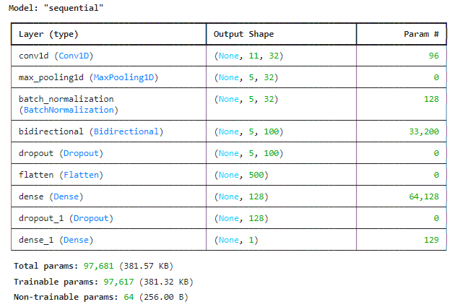

#### **Figure 3.5 Model summary.**

In the Figure 3.5 above, the total params which includes all the learnable parameters in the model are 97,681. The Trainable params which include parameters that the model updates during training are 97,617 and finally the non-trainable params are those parameters that will not be update during training which is 64

### **3.3.6 Model Training and Evaluation**

1. **Model compilation**

* The model was compiled using **Adam optimizer** with input learning rate of 0.0001. The Adam is applied here, among other reasons, because its structure contains the learning rate which conforms to the model during the training process and helps the model to converge well.
* The loss function used is the **binary cross-entropy**, which is suitable for binary classification tasks like predicting heart disease.
* Accuracy is used to measure the performance of the mode by calculating the percentage of the correct predictions during the training
* **EarlyStopping** is used to check the validation loss when training and halts the training process when validation loss does not decrease for the next twenty times (patience=20).

**b. Training the Model:**

* The model is trained using the training dataset (X_train_dl, y_train) for hundred epochs and with batch size of 32. The batch size is the number samples to be used on each epoch during the training.
* Validation is performed using the test dataset (X_test_dl, y_test) during the training to track the model’s performance on unknown data. This helps us assess whether the model is overfitting on the training data or not.

**c. Evaluating the model**

The model is then evaluated using the test dataset (X_test_dl, y_test) to measure its performance. The loss and accuracy are computed, giving a summary of how model will perform on unseen data

**d. Saving the model**

After training and evaluation, the model is saved to. keras extension. This allows us to easily load and use it for predictions without the need to retrain it again.

## **3.3.7 Experimental setup**

In this section, all experiments are carried out on Cleveland datasets from Kaggle. All the computations are conducted on HP AMD Ryzen 3 3250U with Radeon Graphics,8GB RAM, 512 SSD, and a processing speed of 2.60GHz. Additionally, Python programming language is utilized with Anaconda library, Jupiter notebook and TensorFlow in the research

### **3.3.8 Performance Metrics**

After training the model on a given dataset, it has to be evaluated on how well it performs on an unseen data based on the training.

To evaluate the performance of a classification model, different metrics are used, and some of them are as follows:

**Accuracy**: Accuracy measures the proportion of correct predictions out of all predictions made. Accuracy is computed mathematically as

$Accuracy=\frac{TP+TN}{TP+TN+FP+FN}$

Where by True Positive (TP) is the number of correct positive predictions and True negative (TN) is the number of correct negative predictions. Also**,** False Positives (FP) is the number of cases incorrectly predicted as positive and False Negatives (FN) is number of cases incorrectly predicted as negative.

**Precision**: This is the accuracy of all the positive predictions the model have made. Precision is computed as $Precision=\frac{TP}{TP+FP}$

**Recall**: This measures the actual positive instances correctly identified by the model.

Recall is computed mathematically as $Recall=\frac{TP}{TP+FN}$

**F1-Score**: This is the measures of a model’s accuracy on a dataset. The F1-Score is computed as the harmonic mean of Precision and Recall. $F1-score=2*\frac{\begin{aligned}precision* \\ \end{aligned}Recall}{precision+Recall}$

## **3.4 Deployment**

The model is deployed on web application using a streamlit tool. Streamlit is a powerful tool that is use to deploy machine learning and deep leaning model into web-based application where users can use the app wherever they are through internet. This application makes it easier for users to enter the parameters in the form of input text to for the model to predict and bring results.

**CHAPTER FOUR**

# **Results and Discussions**

## **4.0 Introduction**

This chapter covers the detail discussion of the experimental results of the proposed algorithm used to predict heart disease. The various machine learning algorithms such Random Forest, Logistics Regression, 1D CNN, are compared with the proposed hybrid algorithm to see how well the proposed algorithm performs. Performance matrices such as accuracy, precision, recall and f1-score are used to evaluate performance. This discussion will also delve deep into the implications of the results, highlighting the strengths and weaknesses of the proposed format.

## **4.3 Experimental Results**

The outcomes of the various experiments that are carried out during and after training the model. The proposed model’s performance is compared with other traditional machine learning models such as Logistics Regression, Random Forest, as well as the single deep learning algorithms like 1D CNN and Bi-LSTM. The purpose here is to assess, analyze and compare the performance of the proposed model against other models.

## **4.4 Plot of the training history**

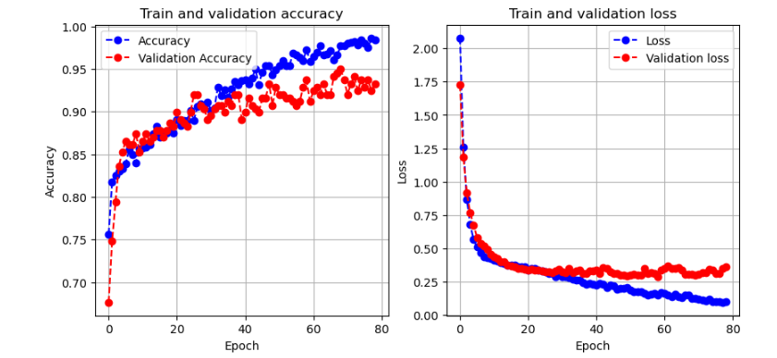

#### **Figure 4.1: Model history plot.**

The Figure 4.1 shows both the Training & Validation Accuracy as well as the Training & Validation Loss. The Training and Validation Accuracy and Loss plots demonstrate the efficiency of the model training and generality ability. Both the training and validation curves increases sharply then stabilize around 93.5% to 94% illustrating that the model is learning well without overtraining. Similarly, the loss values decrease steady and stabilize to around 0.35. This implies that the model has high learnability and generalization, hence the ability to predict outcomes of heart diseases in other unseen data making the model reliable for actual medical use.

## **4.5 The model’s Confusion matrix**

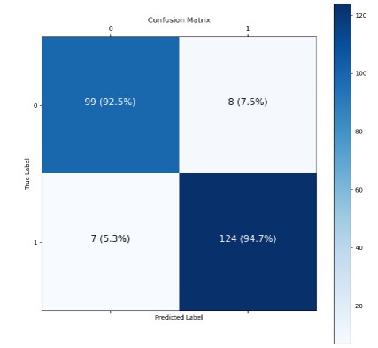

#### **Figure 4.2: Confusion Matrix.**

Figure 4.2 shows the model’s confusion matrix. This shows the number of cases the model predicts correctly and number of cases it misses.

* **True Negatives (TN)**: 99 (92.5%) – All the correct negative instances predicted
* **False Positives (FP)**: 8 (7.5%) – All the positive cases incorrectly predicted.
* **False Negatives (FN)**: 7 (5.3%) – This refers to all the incorrectly predicted negative cases.
* **True Positives (TP)**: 124 (94.7%) – This represents all the correct predicted positive cases.

This confusion matrix gives an overview of how it predicts the heart disease and its performance. The model gives an efficient accuracy of True positive that is 124(94.7%) of disease which can be life threaten if a disease is being missed out. This high prediction means the model has a high sensitivity of detecting diseases.

## **4.6 Comparative Results Table and Plot**

|  |  |  |  |  |
| --- | --- | --- | --- | --- |
| METHODS | ACCURACY | PRECISION | RECALL | F1-SCORE |
| 1D CNN-BI-LSTM (PROPOSED | 94% | 93% | 94% | 94% |
| LOGISTICS REGRESSION | 86 % | 87% | 88% | 87% |
| RANDOM FOREST | 88% | 79% | 80% | 89% |
| 1D CNN | 90% | 89% | 90% | 88% |
| BI-LSTM | 89% | 90% | 89% | 88% |

***Table 4.1: Comparative results of various models***

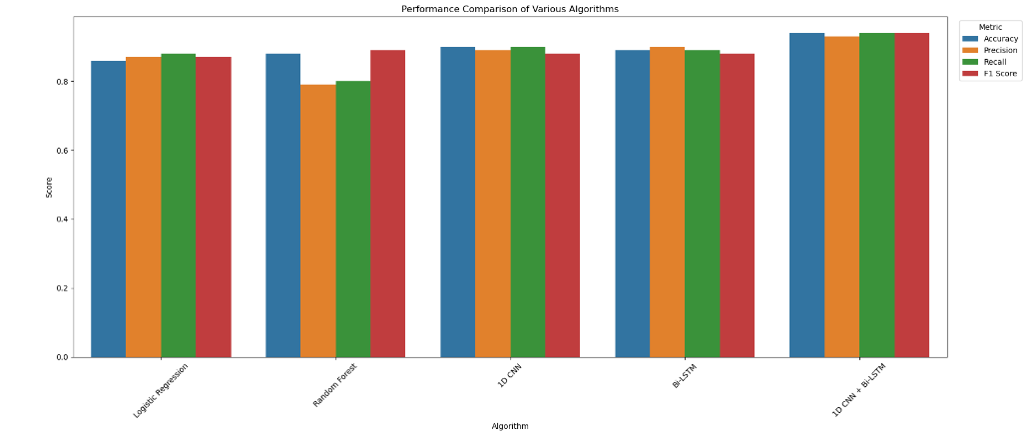

#### **Figure 4.2: Plot of the comparative results**

The Table 4.1 and Figure 4.3 shows the prediction table of how this proposed model is been compared with other different models by the use of various performance matrices. The proposed model at the end of the training achieved an accuracy of 94%, precision of 93%, Recall of 94% and F1- Score of 94%, this high prediction is able to predict correctly the number of patients that have the disease. In heart disease prediction, precision is always crucial to avoid false signals, identifying that patients diagnosed truly have the disease.

Figure 4.2 also describes the histogram plot for the various algorithms using their accuracy, recall, f1-score, and precision. In he plot it is clear that the proposed model has achieved highest accuracy as compare to the rest making it efficient for heart disease prediction.

**CHAPTER FIVE**

# **CONCLUSION**

## **5.1 Summary**

The goal of this study was to develop and implement a hybrid Bidirectional LSTM and 1D Convolution Neural Network model to diagnose and predict heart disease. The objective was to come out with a robust algorithm that is been trained with large dataset to be able to give accurate heart disease predictions. Several studies have been conducted to solve heart disease problems by significantly contributing to early diagnosis and detection. However, upon further research, we realised that, most of the studies made used smaller dataset which scientifically might not be robust enough to give accurate predictions of heat disease. Therefore, it’s necessary that we carry out further study delving deep and using large dataset to conduct the experiment and train a model that will be robust enough to provide high accuracy for heart disease predictions. And at the end of the study, the model provided a significant enhancement in predictive accuracy as compared to some machine learning techniques like Logistic Regression, Random Forest, achieving an accuracy of 94% and precision of 93%,

While the proposed model achieves a significantly high-performance matrix, it misses out some few cases as demonstrated in confusion matrix in figure 7. There are instances where the model makes 5.3% incorrect negative predictions and 7.5% incorrect positive predictions. As far as human live is very important, little errors can cause a significant problem so such wrong predictions have to be avoided.

We intend exploring more and integrating larger dataset to leverage its robustness and enhance the prediction accuracy

## **5.2 Conclusion**

An important key feature of the proposed model lies in its ability to entail both sequential and spatial pattern in the data, the combination of these two algorithms gives an extraction and sequential modelling. This architecture enables it to handle complex, time dependent more effectively ensuring higher recall and accuracy making it more useful in the healthcare facilities, where early detection and accuracy of heart disease can help to improve patient outcome.

Comparing the performance of the proposed model against other models either those we experiment or those captured in the literature review, it is clear that the proposed model is ahead of them with accuracy of 94%, precision of 93%, recall of 94% and f1-score of 94% and this makes it suitable and robust as far as heart disease prediction is concerned

This research presents a promising step forward with more accuracy and efficient heart disease prediction. The hybrid 1D CNN and Bi-LSTM model not only raises the bar for predictive accuracy but also provide new way for integrating more advanced deep learning tools in healthcare sector. With further development, this approach could become an essential tool in improving patients care and reducing heart disease mortality rates.

## **5.3 Recommendation**

Based on the results and finding, several recommendations have been proposed for future improvement of the proposed method.

Future work could focus on optimizing the model to capture all possible cases to make complete and correct predictions with high accuracy, which is essential in medical diagnostics to avoid missed diagnoses.

This project is still open for further study where future researchers can train the model with huge dataset which can make it more robust and increase it prediction capacity to handle complex case.

Incorporating additional clinical features could also be considered for future studies. Adding more clinical features to the model provide more insight and improve the prediction accuracy making it more holistic approach

**References**

Ali, S. A., Raza, B., Malik, A. K., Shahid, A. R., Faheem, M., Alquhayz, H., & Kumar, Y. J. (2020). An Optimally Configured and Improved Deep Belief Network (OCI-DBN) Approach for Heart Disease Prediction Based on Ruzzo-Tompa and Stacked Genetic Algorithm. *IEEE Access*, *8*, 65947–65958. https://doi.org/10.1109/ACCESS.2020.2985646

Almazroi, A. A., Aldhahri, E. A., Bashir, S., & Ashfaq, S. (2023). A Clinical Decision Support System for Heart Disease Prediction Using Deep Learning. *IEEE Access*, *11*, 61646–61659. https://doi.org/10.1109/ACCESS.2023.3285247

Alzakari, S. A., Menaem, A. A., Omer, N., Abozeid, A., Hussein, L. F., Abass, I. A. M., Rami, A., & Elhadad, A. (2024). Enhanced heart disease prediction in remote healthcare monitoring using IoT-enabled cloud-based XGBoost and Bi-LSTM. *Alexandria Engineering Journal*, *105*, 280–291. https://doi.org/10.1016/j.aej.2024.06.036

Bengio, Y., Goodfellow, I., & Courville, A. (2017). *Deep learning* (Vol. 1). Cambridge, MA, USA: MIT press.

El-Shafiey, M. G., Hagag, A., El-Dahshan, E.-S. A., & Ismail, M. A. (2021). A Hybrid Bidirectional LSTM and 1D CNN for Heart Disease Prediction. *IJCSNS International Journal of Computer Science and Network Security*, *21*(10), 135. https://doi.org/10.22937/IJCSNS.2021.21.10.18

Kumari, D. (2021). *Study Of Heart Disease Prediction Using Cnn Algorithm* (Vol. 8). www.jetir.org

Kumari, D. (2021). *study of heart disease prediction using cnn algorithm* (Vol. 8). www.jetir.org

Li, Y., He, Y., & Zhang, M. (2020). Prediction of Chinese energy structure based on Convolutional Neural Network-Long Short-Term Memory (CNN-LSTM). *Energy Science and Engineering*, *8*(8), 2680–2689. <https://doi.org/10.1002/ese3.698>

M. Kavitha, G. Gnaneswar, R. Dinesh, Y.R. Sai, R.S. Suraj, Heart disease prediction using hybrid machine learning, Model (2021), https://doi.org/10.1109/ ICICT50816.2021.9358597.

Manur, M., Pani, A. K., & Kumar, P. (2020). A prediction technique for heart disease based on long short-term memory recurrent neural network. *International Journal of Intelligent Engineering and Systems*, *13*(2), 31–39. https://doi.org/10.22266/ijies2020.0430.04

Mohan, S., Thirumalai, C., & Srivastava, G. (2019). Effective heart disease prediction using hybrid machine learning techniques. *IEEE access*, *7*, 81542-81554.

Muthu Ganesh, V., & Nithiyanantham, J. (2022). Heuristic-based channel selection with enhanced deep learning for heart disease prediction under WBAN. *Computer Methods in Biomechanics and Biomedical Engineering*, *25*(13), 1429–1448. https://doi.org/10.1080/10255842.2021.2013828

Naqa, I. E., & Murphy, M. J. (2015). What is machine learning? In *Springer eBooks* (pp. 3–11). https://doi.org/10.1007/978-3-319-18305-3_1

Reshan, M. S. Al, Amin, S., Zeb, M. A., Sulaiman, A., Alshahrani, H., & Shaikh, A. (2023). A Robust Heart Disease Prediction System Using Hybrid Deep Neural Networks. *IEEE Access*, *11*, 121574–121591. https://doi.org/10.1109/ACCESS.2023.3328909

Sharma, R., & Singh, S. N. (2022). Towards Accurate Heart Disease Prediction System: An Enhanced Machine Learning Approach. *International Journal of Performability Engineering*, *18*(2), 136–148. https://doi.org/10.23940/ijpe.22.02.p8.136148

Shrivastava, P. K., Sharma, M., sharma, P., & Kumar, A. (2023). HCBiLSTM: A hybrid model for predicting heart disease using CNN and BiLSTM algorithms. *Measurement: Sensors*, *25*. <https://doi.org/10.1016/j.measen.2022.100657>

W. A. W. A. Bakar, N. L. N. B. Josdi, M. B. Man and M. A. B. Zuhairi, "A Review: Heart Disease Prediction in Machine Learning & Deep Learning," *2023 19th IEEE International Colloquium on Signal Processing & Its Applications (CSPA)*, Kedah, Malaysia, 2023, pp. 150-155, Doi: 10.1109/CSPA57446.2023.10087837.

 World Health Organization (WHO). (2020). Cardiovascular Diseases (CVDs). Retrieved from <https://www.who.int/news-room/fact-sheets/detail/cardiovascular-diseases-(cvds)>

Yang, J., Huang, X., Wu, H., & Yang, X. (2020). EEG-based emotion classification based on bidirectional long short-term memory network. *Procedia Computer Science*, *174*, 491-504.

# 

# Appendix

## **Codes for the model building**

**# Build the hybrid model**

**model = Sequential()**

**model.add(Input(shape=(X_train_dl.shape[1], X_train_dl.shape[2])))**

**model.add(Conv1D(filters=32, kernel_size=2, activation='relu'))**

**#model.add(Dropout(0.2))**

**model.add(MaxPooling1D(pool_size=2))**

**model.add(BatchNormalization(momentum=0.99))**

**model.add(Bidirectional(LSTM(50, return_sequences=True)))**

**model.add(Dropout(0.5))**

**model.add(Flatten())**

**model.add(Dense(128, activation='relu', kernel_regularizer=tf.keras.regularizers.l2(0.01)))**

**model.add(Dropout(0.5))**

**model.add(Dense(1, activation='sigmoid'))**

## **Interface of the web app**

